# Google Dork-Based Asset Discovery Report

## Target Domains

-nitt.edu

---

## A. Public Documents

**Google Dorks Used:**

- `site:nitt.edu filetype:pdf`

- `site:nitt.edu filetype:docx`

- `site:nitt.edu filetype:xlsx`

**Findings:**

1. <http://csrl.nitt.edu/nyquist.pdf>
2. <https://nitt.edu/home/EEE_ATAL_FDP_2021.pdf>
3. <https://nitt.edu/home/Peer_Supporters_2017.pdf>
4. <https://www.nitt.edu/home/students/facilitiesnservices/hospital/awareness/PMJAYPRIVATEHOSPITALSCONSOLIDATED.xls>
5. <http://silver.nitt.edu/~esgopi/mfiles/citationindex/All%20Metrics.xlsx>
6. <https://sec2024.nitt.edu/ExtendedAbstract.docx>
7. <http://npec2019.nitt.edu/download/Payment_Form.docx>
8. <https://www.nitt.edu/home/academics/ug_section/FORMAT_RECORD_ATTENDANCE_BOOK_ACADEMIC_WORK_2023.docx>

A lot of documents are publicly available on the website.

---

## B. Login Pages / Admin Panels

**Google Dorks Used:**

- `site:nitt.edu inurl:admin`

- `site:nitt.edu intitle:"login"`

**Findings:**

1. <https://scholarship.nitt.edu/auth/admin/login>

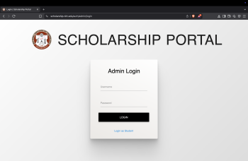

1. <https://webmail.nitt.edu/mailman/admin/bwc>
2. <https://courses.nitt.edu/moodle41/admin/tool/dataprivacy/summary.php>
3. <https://nitt.edu/home/academics/departments/ece/faculty/malark/+login&subaction=register&reSendKey=1>
4. <https://nitt.edu/home/academics/departments/dee/eve/+login>
5. <https://nitt.edu/home/academics/departments/ece/faculty/malark/+login&subaction=register&reSendKey=1>

## C.Public Backup / Config Files

**Google Dorks Used:**

site:nitt.edu inurl:backup

**Findings:**

1. <http://vr360.nitt.edu/dashboard/docs/backup-restore-mysql.html>

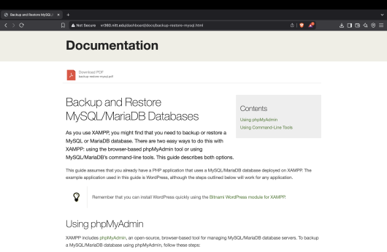

## D.Exposed Logs / Errors

**Google Dorks Used:**

site:nitt.edu ext:log

site:nitt.edu intext:"Error:"

**Findings:**

##E.Emails & Contact Info

**Google Dorks Used:**

-site:nitt.edu intext:@nitt.edu

-site:nitt.edu inurl:contact

**Findings:**

1. <https://www.nitt.edu/home/academics/departments/eee/people/faculty>
2. <https://www.nitt.edu/home/academics/contact_details>

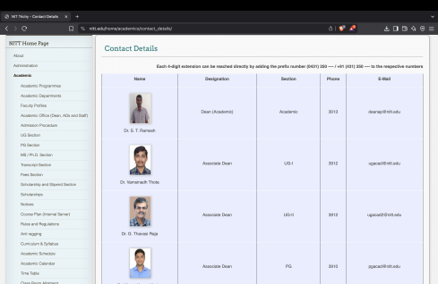

##F.Git Folders and Env Files

**Google Dorks Used:**

- `site:nitt.edu inurl:.git`

- `site:nitt.edu ext:env`

**Findings:**

1. <http://vr360.nitt.edu/dashboard/docs/deploy-git-app.html>

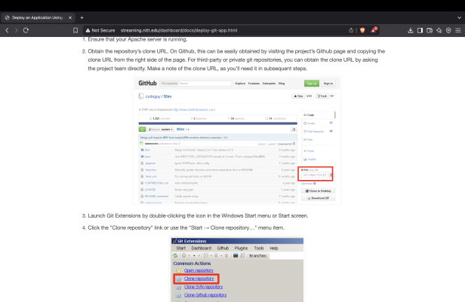

## Ethical Note

This report was created strictly for educational and ethical cybersecurity learning. No data was exploited, and all access remained within the bounds of public indexing.

Task by:- Abhay Pratap Singh